1.ARRAY OPERATIONS USING C++
AIM:
To write and implement C++ programs to perform various operations on one-dimensional and two-dimensional arrays, such as reading and displaying elements, searching, reversing, finding the smallest and largest elements, calculating the sum, merging arrays, and finding the transpose of a matrix
1.1.Write a c++ program to read and display array elements
ALGORITHM:
Step 1: Start the program.
Step 2: Declare an array and a variable to store the number of elements.
Step 3: Read the number of elements n.
Step 4: Read n elements into the array.
Step 5: Traverse the array from the first element to the last element.
Step 6: Display all the array elements.
Step 7: Stop the program.

PROGRAM:
#include<iostream>
using namespace std;
int main()
{
int arr[100],n;
cout<<"enter the number of elements:";
cin>>n;
cout<<"Enter"<<n<<"elements";
for(int i=0;i<n;i++)
cin>>arr[i];
cout<<"Array elemens are:";
for(int i=0;i<n;i++)
cout<<arr[i]<<"";
return 0;
}
OUTPUT:
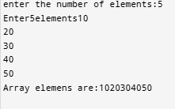

1.2. Write a c++ program to search an element
ALGORITHM:
Step 1: Start the program.
Step 2: Declare an array, the number of elements n, and the search element key.
Step 3: Read the number of elements n.
Step 4: Read n elements into the array.
Step 5: Read the element to be searched.
Step 6: Compare the search element with each array element.
Step 7: If the element is found, display its position.
Step 8: If the element is not found, display "Element not found."
Step 9: Stop the program.

PROGRAM:
#include <iostream>
using namespace std;
int main()
{
int n, key;
cout << "Enter the number of elements: ";
cin >> n;
int arr[n];
cout << "Enter the elements: ";
for (int i = 0; i < n; i++)
{
cin >> arr[i];
}
cout << "Enter the element to search: ";
cin >> key;
bool found = false;
for (int i = 0; i < n; i++) {
if (arr[i] == key) {
cout << "Element found at position " << i + 1 << endl;
found = true;
break;
}
}
if (!found)
{
cout << "Element not found." << endl;
}
return 0;}

OUTPUT:
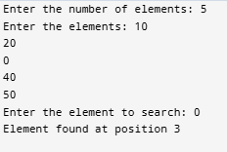
1.3. Write a c++ program to reverse an array

ALGORITHM:
Step 1: Start the program.
Step 2: Declare an array and a variable to store the number of elements.
Step 3: Read the number of elements n.
Step 4: Read n elements into the array.
Step 5: Swap the first element with the last element and continue swapping towards the middle.
Step 6: Display the elements of the reversed array.
Step 7: Stop the program.

PROGRAM:
#include <iostream>
using namespace std;
int main() {
int n;
cout << "Enter the number of elements: ";
cin >> n;
int arr[n];
cout << "Enter the elements: ";
for (int i = 0; i < n; i++) {
cin >> arr[i];
}
for (int i = 0; i < n / 2; i++) {
int temp = arr[i];
arr[i] = arr[n - 1 - i];
arr[n - 1 - i] = temp;
}
cout << "Reversed array: ";
for (int i = 0; i < n; i++) {
cout << arr[i] << " ";
}
return 0;
}

OUTPUT:
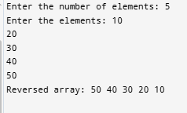

Single Dimension Array
1.4.Find the Smallest and Largest element

ALGORITHM:
Step 1: Start the program.
Step 2: Declare an array and a variable to store the number of elements.
Step 3: Read the number of elements n.
Step 4: Read n elements into the array.
Step 5: Assume the first element as the smallest and largest element.
Step 6: Compare each remaining element with the smallest and largest values.
Step 7: Update the smallest value if a smaller element is found.
Step 8: Update the largest value if a larger element is found.
Step 9: Display the smallest and largest elements.
Step 10: Stop the program.

PROGRAM:
#include <iostream>
using namespace std;
int main() {
int n;
cout << "Enter the number of elements: ";
cin >> n;
int arr[n];
cout << "Enter the elements: ";
for (int i = 0; i < n; i++) {
cin >> arr[i];
}
int smallest = arr[0];
int largest = arr[0];
for (int i = 1; i < n; i++) {
if (arr[i] < smallest)
smallest = arr[i];

if (arr[i] > largest)
largest = arr[i];
}
cout << "Smallest element: " << smallest << endl;
cout << "Largest element: " << largest << endl;
return 0;
}
OUTPUT:
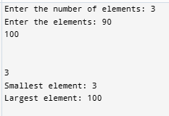

1.5. Find the sum of all element

ALGORITHM:
Step 1: Start the program.
Step 2: Declare an array, a variable for the number of elements, and initialize sum to zero.
Step 3: Read the number of elements n.
Step 4: Read n elements into the array.
Step 5: Traverse the array from the first element to the last element.
Step 6: Add each array element to sum.
Step 7: Display the sum of all the elements.
Step 8: Stop the program.

PROGRAM:
#include <iostream>
using namespace std;
int main() {
int n, sum = 0;
cout << "Enter the number of elements: ";
cin >> n;
int arr[n];
cout << "Enter the elements: ";
for (int i = 0; i < n; i++) {
cin >> arr[i];
}
for (int i = 0; i < n; i++) {
sum += arr[i];
}
cout << "Sum of all elements = " << sum << endl;
return 0;
}

OUTPUT:
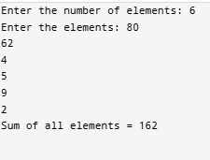
Multi Dimensional Array
1.6. Write a c++ program to merge two array

ALGORITHM:
Step 1: Start the program.
Step 2: Declare two arrays, a merged array, and variables to store their sizes.
Step 3: Read the number of elements in the first array.
Step 4: Read the elements of the first array.
Step 5: Read the number of elements in the second array.
Step 6: Read the elements of the second array.
Step 7: Copy all elements of the first array into the merged array.
Step 8: Copy all elements of the second array after the elements of the first array.
Step 9: Display the merged array.
Step 10: Stop the program.

PROGRAM:
#include <iostream>
using namespace std;
int main() {
int n1, n2;
cout << "Enter the number of elements in first array: ";
cin >> n1;
int arr1[n1];
cout << "Enter the elements of first array: ";
for (int i = 0; i < n1; i++) {
cin >> arr1[i];
}
cout << "Enter the number of elements in second array: ";
cin >> n2;
int arr2[n2];
cout << "Enter the elements of second array: ";
for (int i = 0; i < n2; i++) {
cin >> arr2[i];
}
int merged[n1 + n2];
for (int i = 0; i < n1; i++) {
merged[i] = arr1[i];
}
for (int i = 0; i < n2; i++) {
merged[n1 + i] = arr2[i];
}
cout << "Merged array: ";
for (int i = 0; i < n1 + n2; i++) {
cout << merged[i] << " ";
}
return 0;
}

OUTPUT:
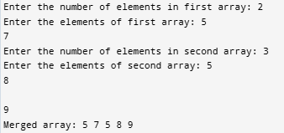

1.7. Write a c++ program in 2D array to read and display array elements

ALGORITHM:
Step 1: Start the program.
Step 2: Declare a two-dimensional array and variables for rows and columns.
Step 3: Read the number of rows and columns.
Step 4: Read the elements of the 2D array using nested loops.
Step 5: Traverse the array row by row using nested loops.
Step 6: Display all the elements of the 2D array.
Step 7: Stop the program.

PROGRAM:
#include <iostream>
using namespace std;
int main() {
int rows, cols;
cout << "Enter the number of rows: ";
cin >> rows;
cout << "Enter the number of columns: ";
cin >> cols;
int arr[10][10];
cout << "Enter the array elements:\n";
for (int i = 0; i < rows; i++) {
for (int j = 0; j < cols; j++) {
cin >> arr[i][j];
}
}
cout << "\nThe array elements are:\n";
for (int i = 0; i < rows; i++) {
for (int j = 0; j < cols; j++) {
cout << arr[i][j] << " ";
}
cout << endl;
}
return 0;
}

OUTPUT:
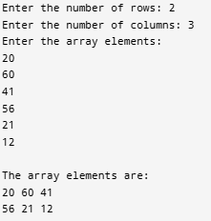

1.8. Write a c++ program in 2D array Transpose of a matrix

ALGORITHM:
Step 1: Start the program.
Step 2: Declare a two-dimensional array and variables for rows and columns.
Step 3: Read the number of rows and columns.
Step 4: Read the matrix elements.
Step 5: Display the original matrix.
Step 6: Interchange the row and column positions while displaying the elements.
Step 7: Display the transpose of the matrix.
Step 8: Stop the program.

PROGRAM:
#include <iostream>
using namespace std;
int main() {
int rows, cols;
cout << "Enter the number of rows: ";
cin >> rows;
cout << "Enter the number of columns: ";
cin >> cols;
int arr[10][10];
cout << "Enter the matrix elements:\n";
for (int i = 0; i < rows; i++) {
for (int j = 0; j < cols; j++) {
cin >> arr[i][j];
}
}
cout << "\nOriginal Matrix:\n";
for (int i = 0; i < rows; i++) {
for (int j = 0; j < cols; j++) {
cout << arr[i][j] << " ";
}
cout << endl;
}
cout << "\nTranspose of the Matrix:\n";
for (int i = 0; i < cols; i++) {
for (int j = 0; j < rows; j++) {
cout << arr[j][i] << " ";
}
cout << endl;
}
return 0;
}
OUTPUT:
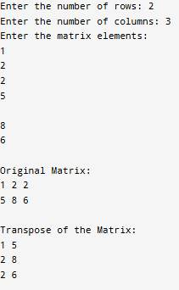

1.9. Write a c++ program in 2D array to reverse an array

ALGORITHM:
Step 1: Start the program.
Step 2: Declare a two-dimensional array and variables for rows and columns.
Step 3: Read the number of rows and columns.
Step 4: Read the matrix elements.
Step 5: Traverse each row from the last column to the first column.
Step 6: Display the elements of each row in reverse order.
Step 7: Display the reversed matrix.
Step 8: Stop the program.

PROGRAM:
#include <iostream>
using namespace std;
int main() {
int r,c;
cout << "Enter the number of rows and columns: ";
cin >> r>>c;
int arr[r][c];
cout << "Enter the matrix elements:\n";
for (int i = 0; i < r; i++) {
for (int j = 0; j < c; j++) {
cin >> arr[i][j];
}
}
cout << "Reversed Matrix:\n";
for (int i = 0; i < r; i++) {
for (int j =c-1; j >=0; j--) {
cout << arr[i][j] << " ";
}
cout << endl;
}
return 0;
}
OUTPUT:
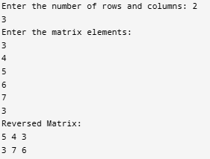
RESULT:
Thus, the C++ programs for performing various operations on one-dimensional and two-dimensional arrays were successfully implemented and executed. The programs correctly performed array reading, displaying, searching, reversing, finding minimum and maximum elements, calculating the sum, merging arrays, finding the transpose, and reversing a 2D array.

